Mean Stack Application – Project Manager

Application Structure:

* Client side – Angular
* Server side – Express
* Database – MongoDB

Required Software’s:

* Node JS
* MongoDB
* Visual Studio Code (Any IDE)
* Robo Mongo (Any IDE)
* Docker
* Jenkins

Client Side – Angular

Angular CLI for building the UI and connects with REST endpoints exposed from server side (express)

**Add User:**

* **Before Adding User**

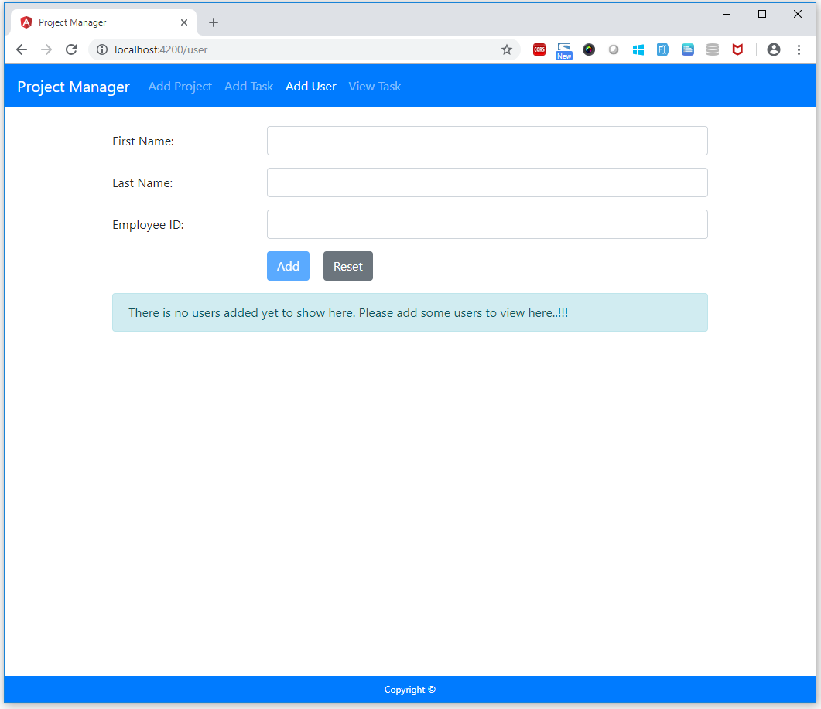

* **After adding User:**

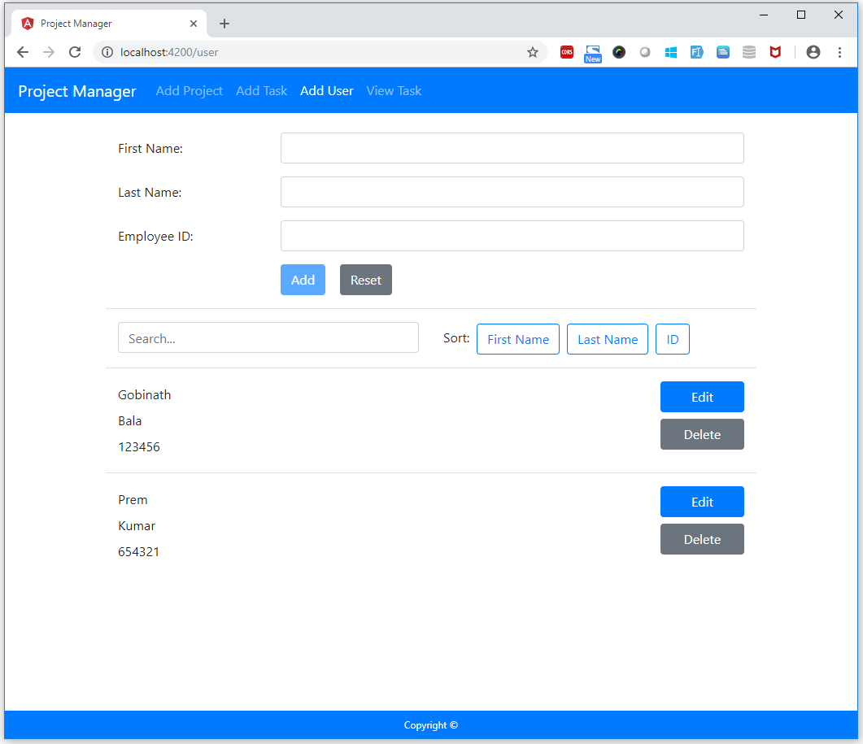

**Add Project:**

* **Before Adding Project:**

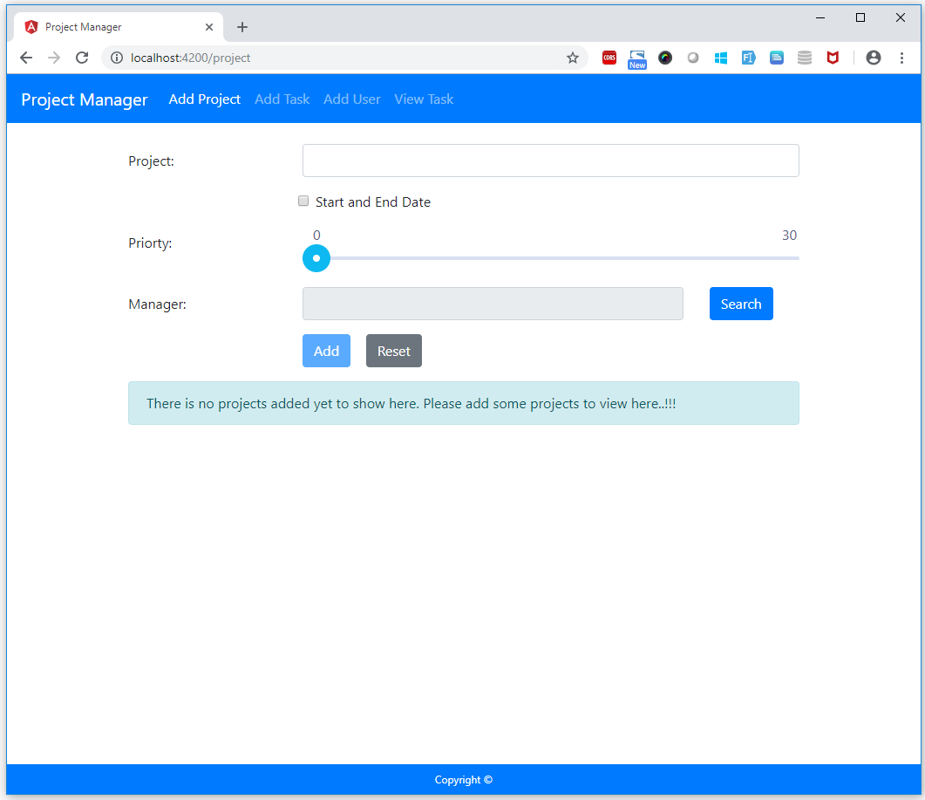

* **After Adding Project:**

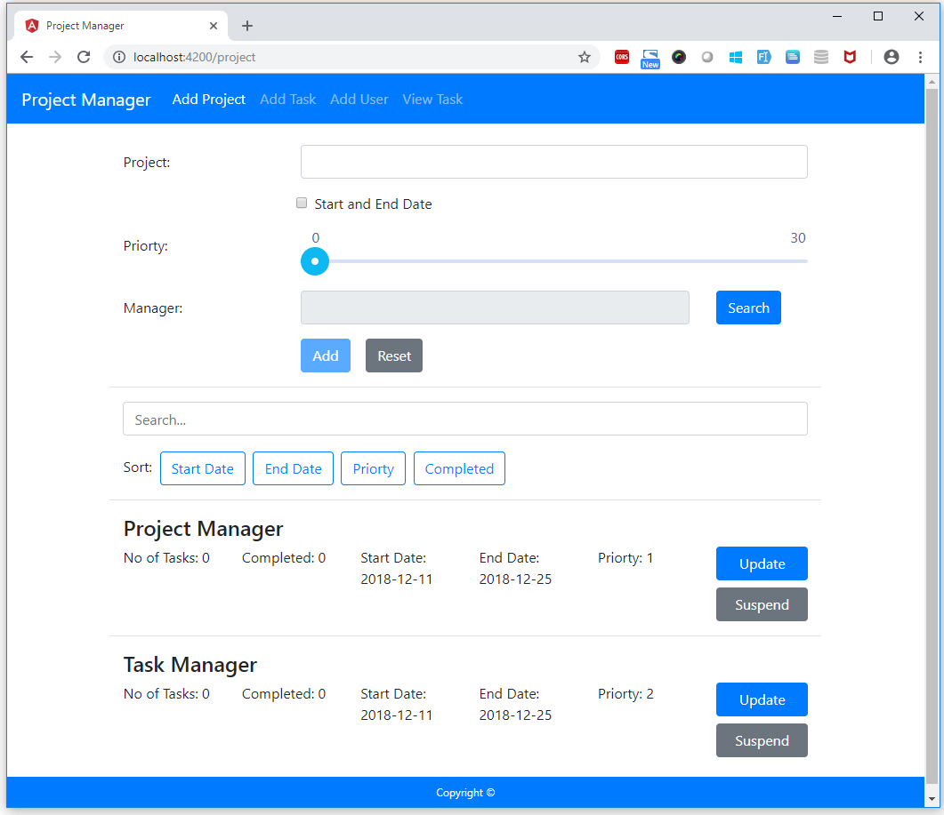

**Add Task:**

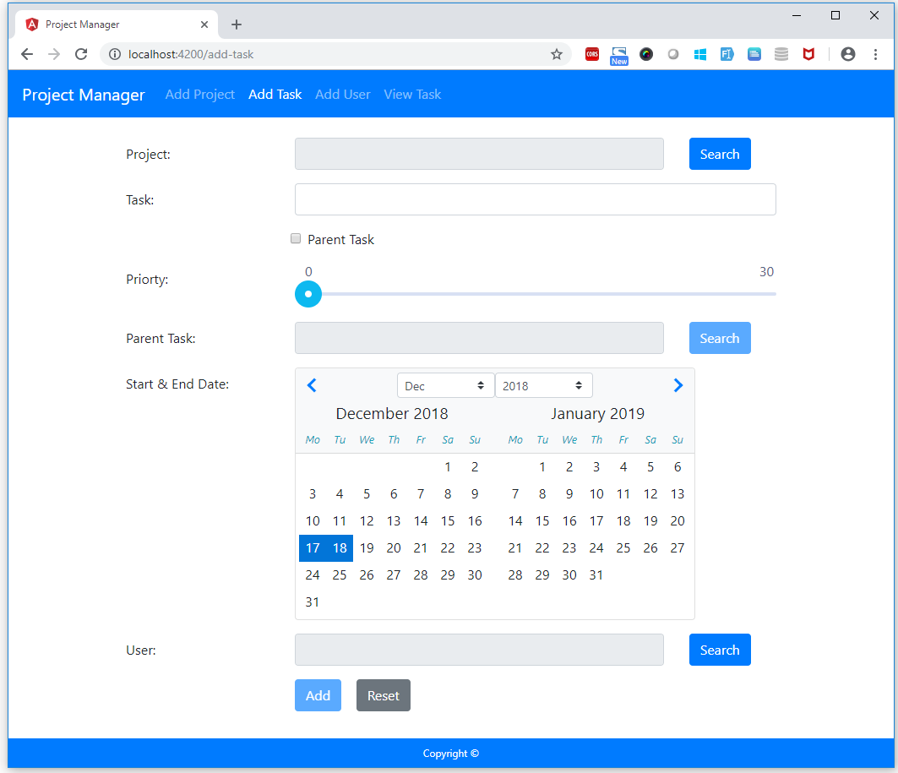

**View Task:**

* **Before Adding Task:**

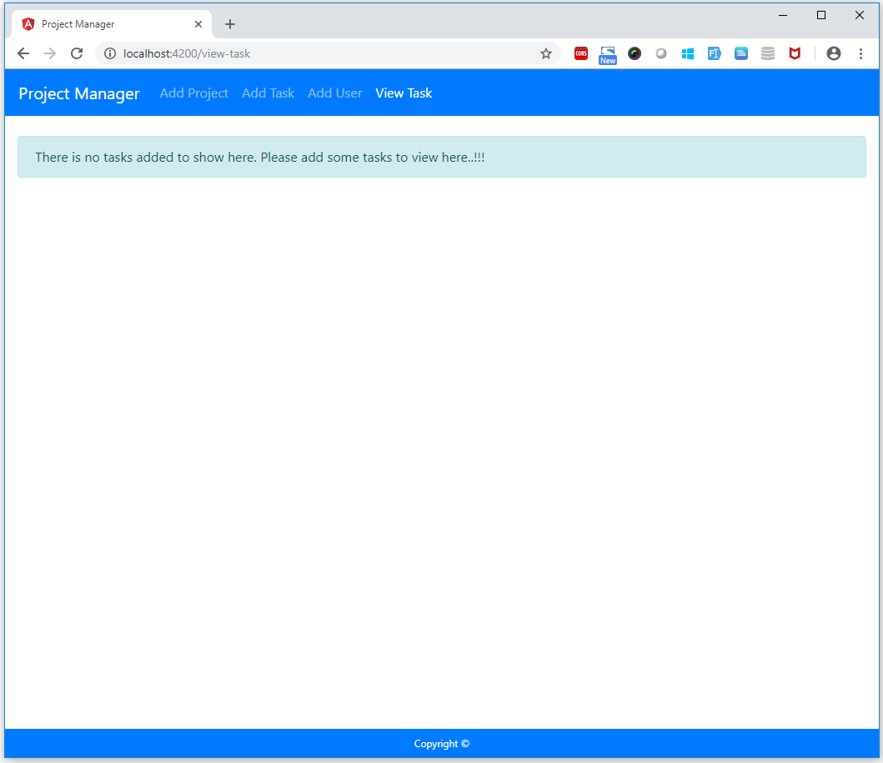

* **After Adding Task:**

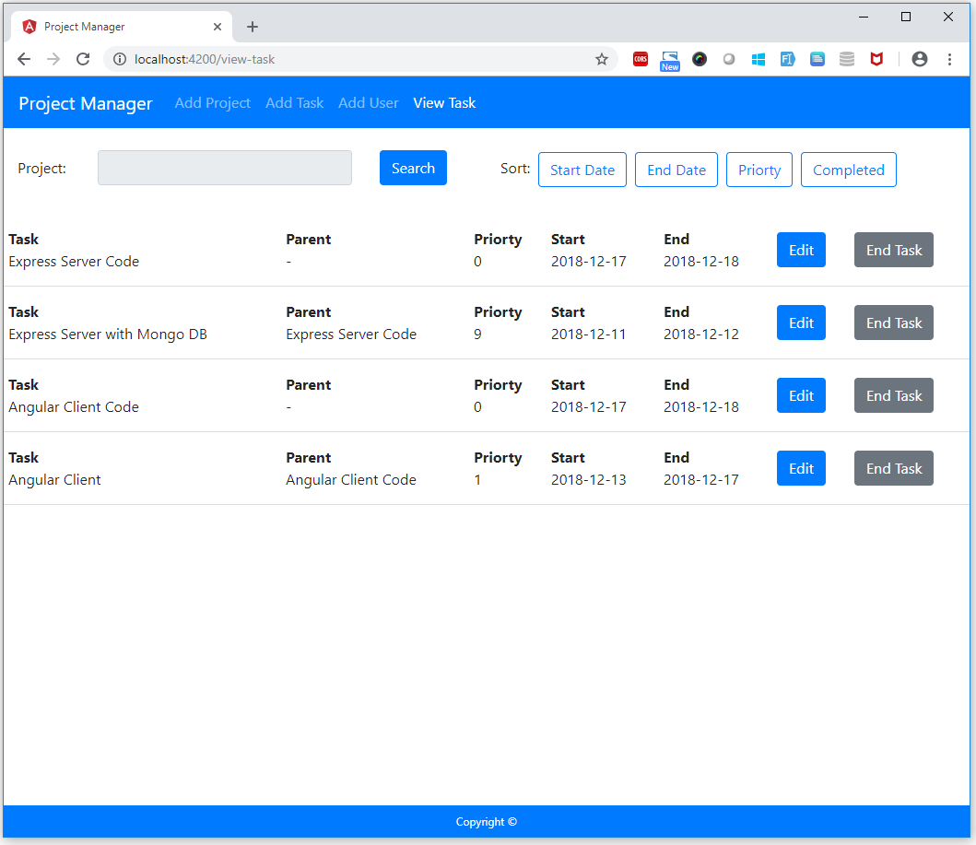

**Edit Task:**

* **With Parent Task:**

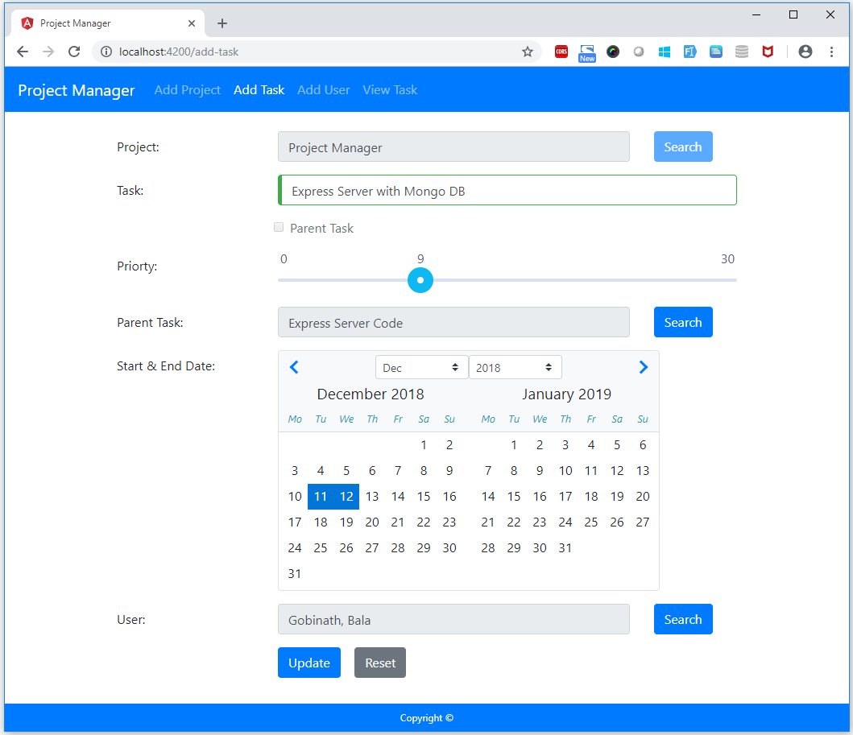

* **Without Parent Task:**

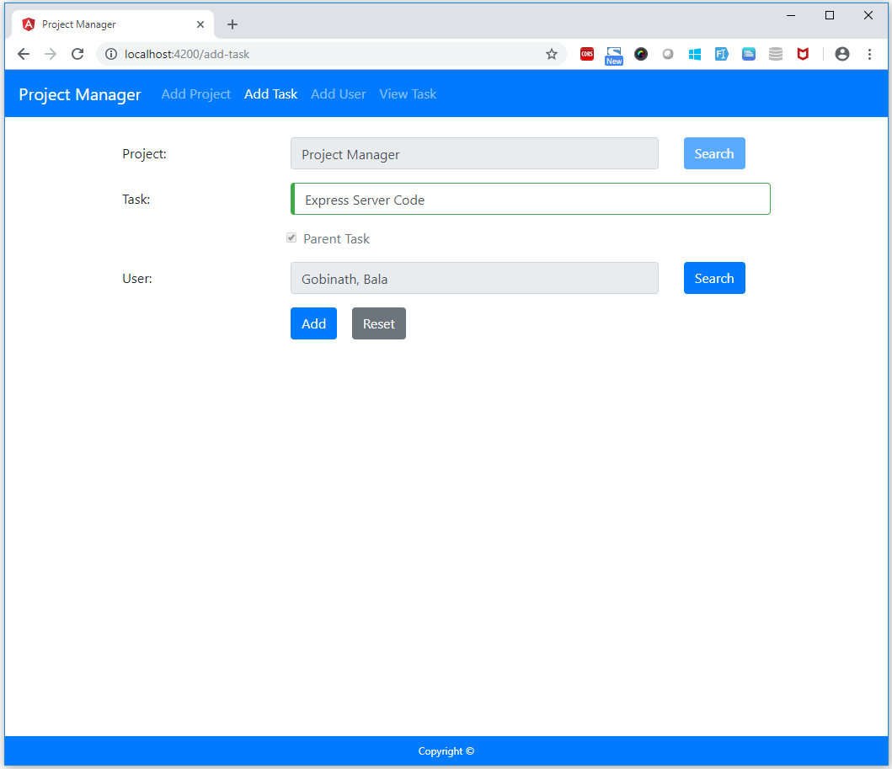

Server Side – Express

Express JS for exposing REST endpoints with MongoDB.

**Add User – POSTMAN:**

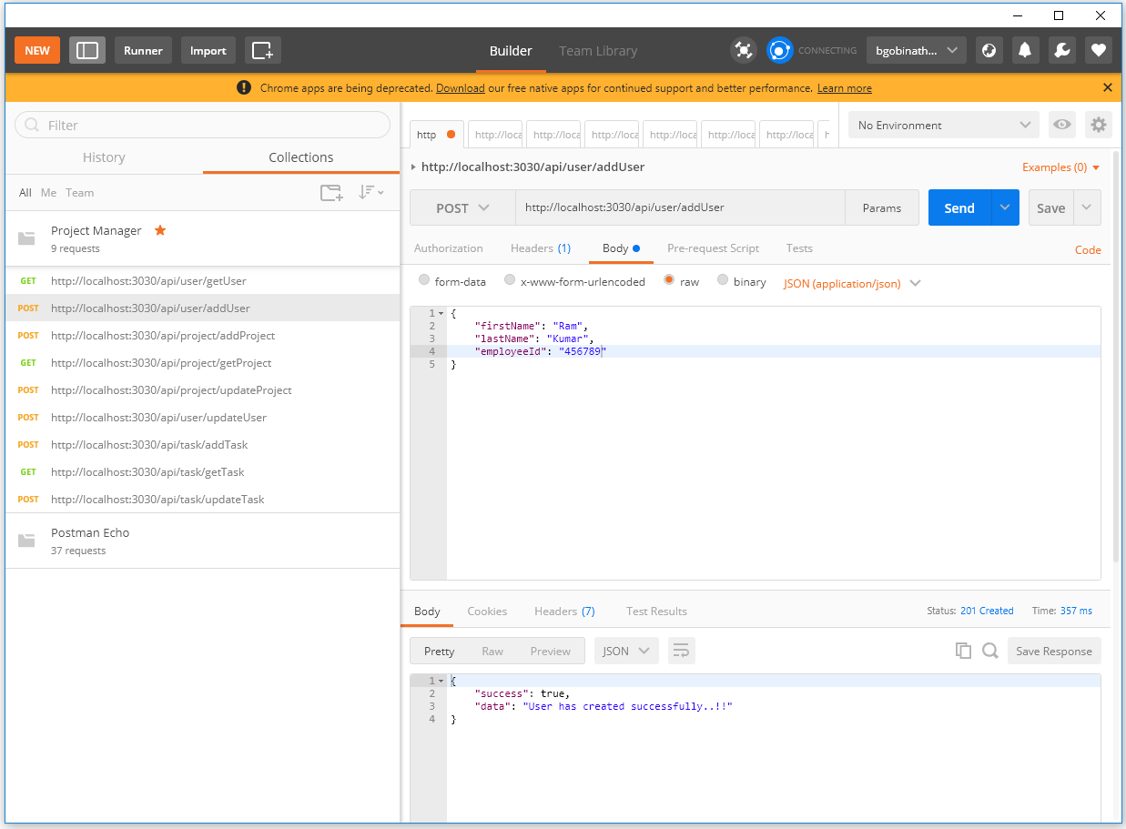

**Add User – MongoDB:**

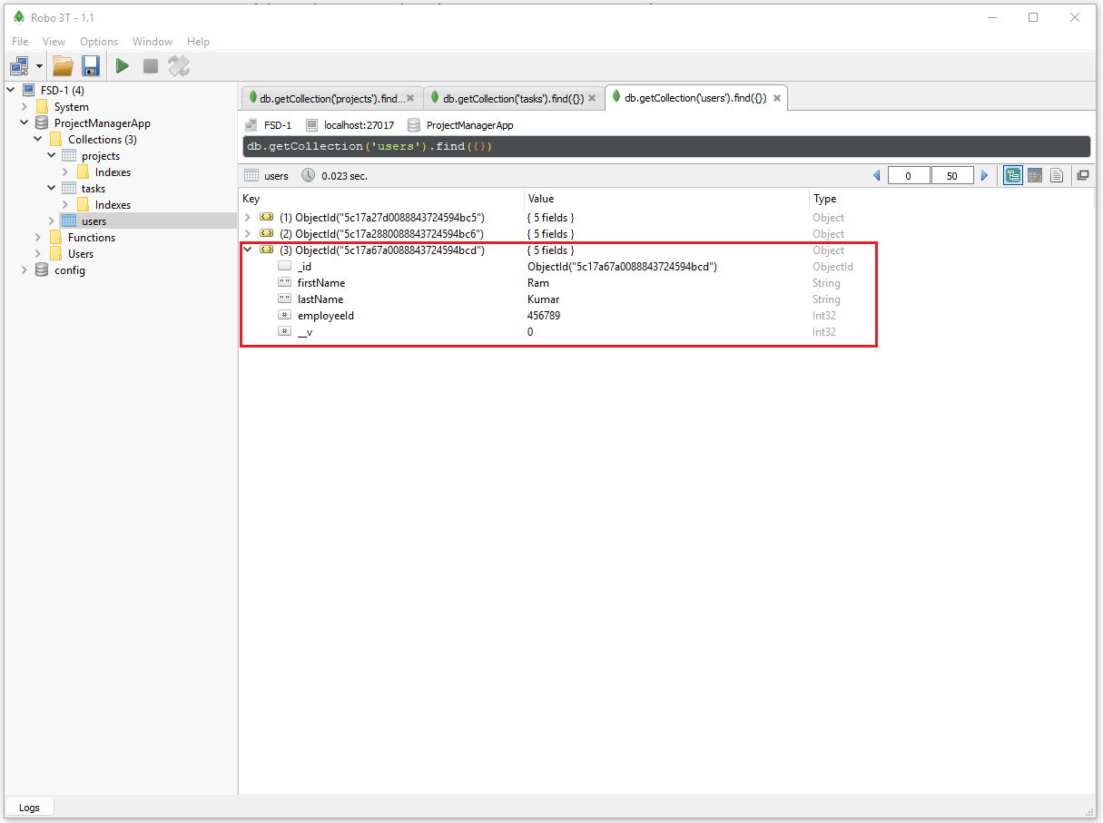

**View User – Postman:**

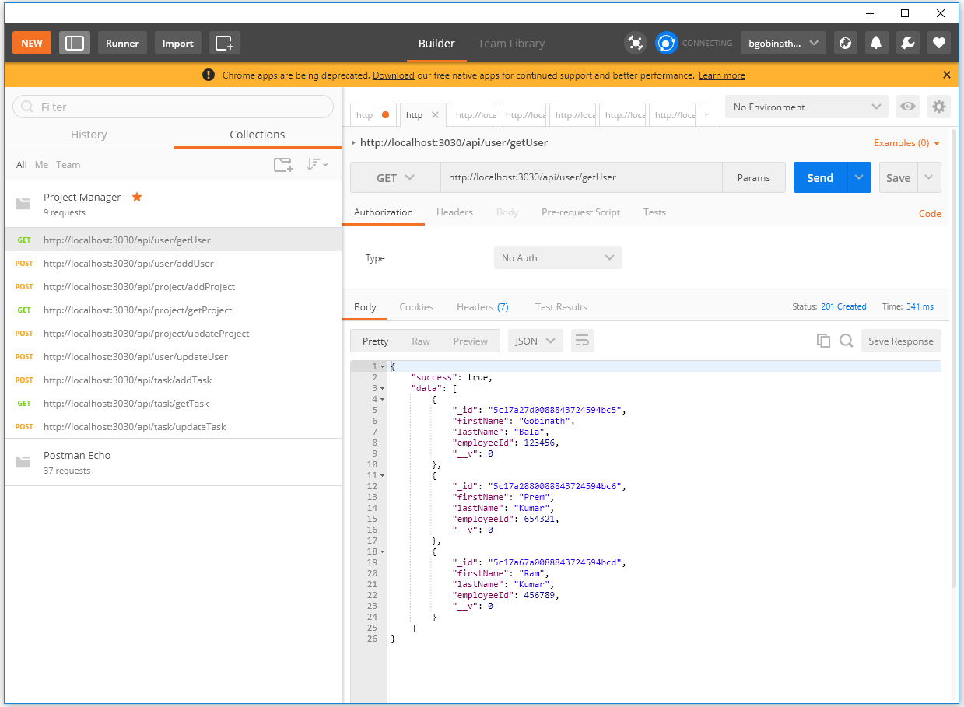

**View User – MongoDB:**

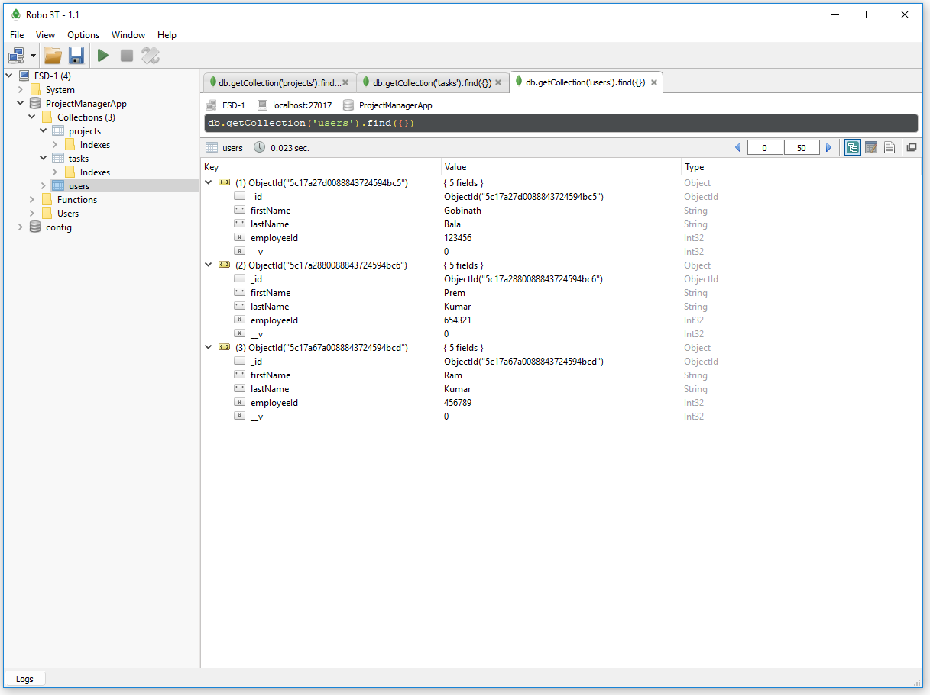

**Delete User – Postman:**

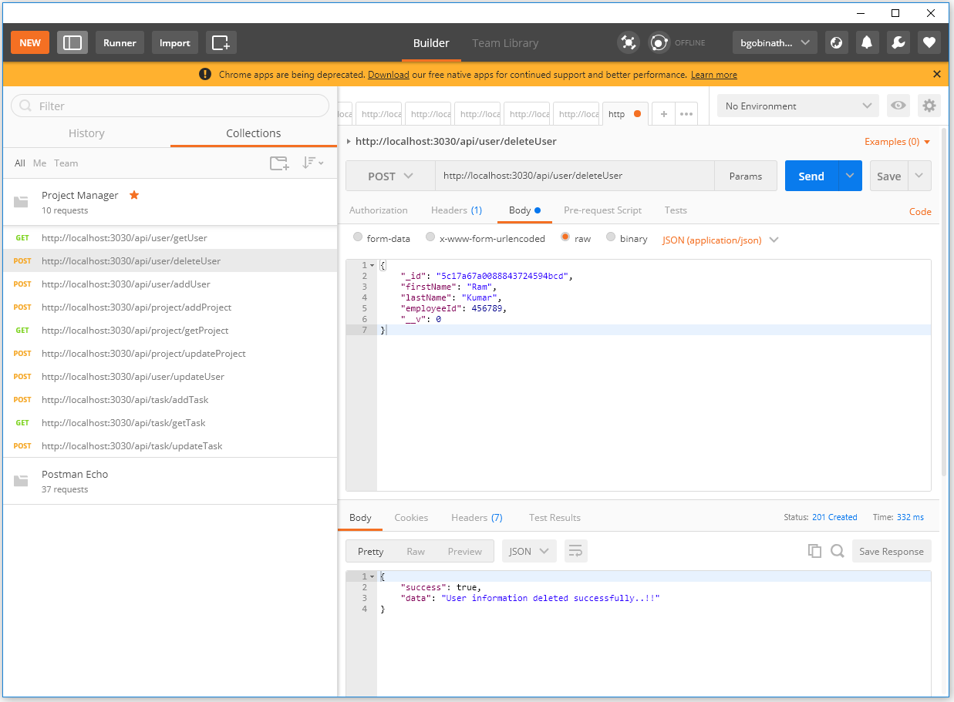

**Update User – Postman:**

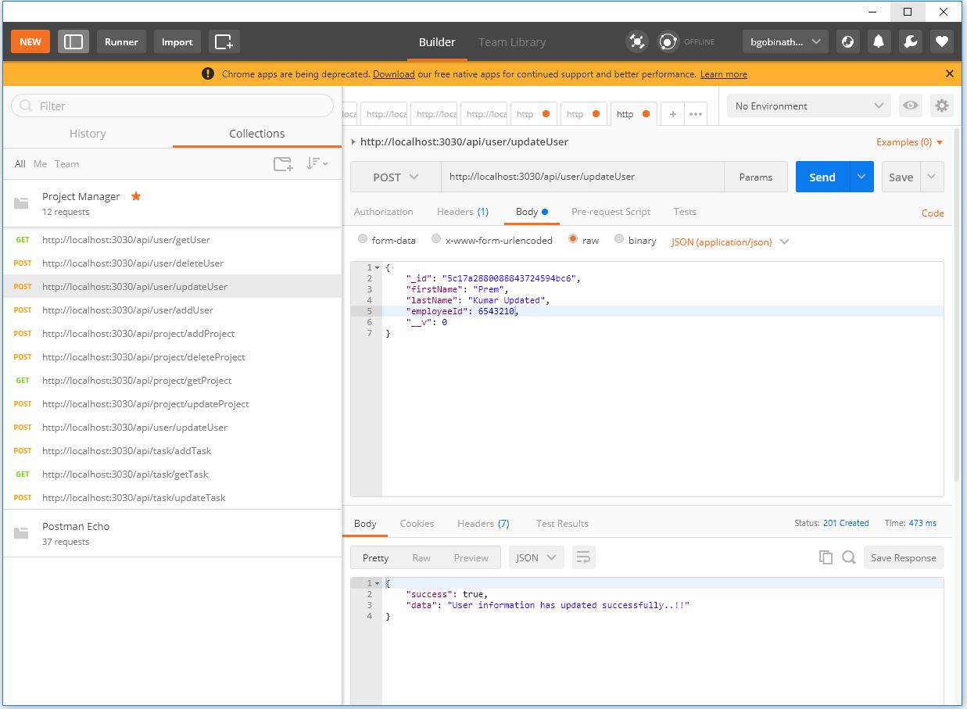

**Add Project – Postman:**

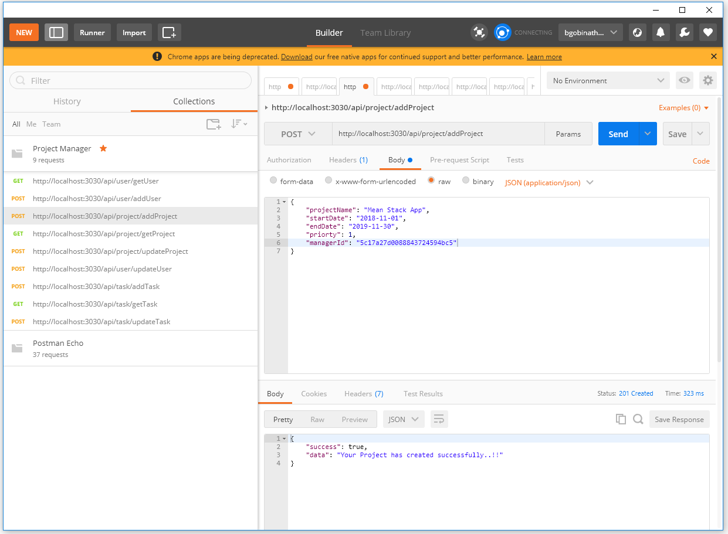

**Add Project – MongoDB:**

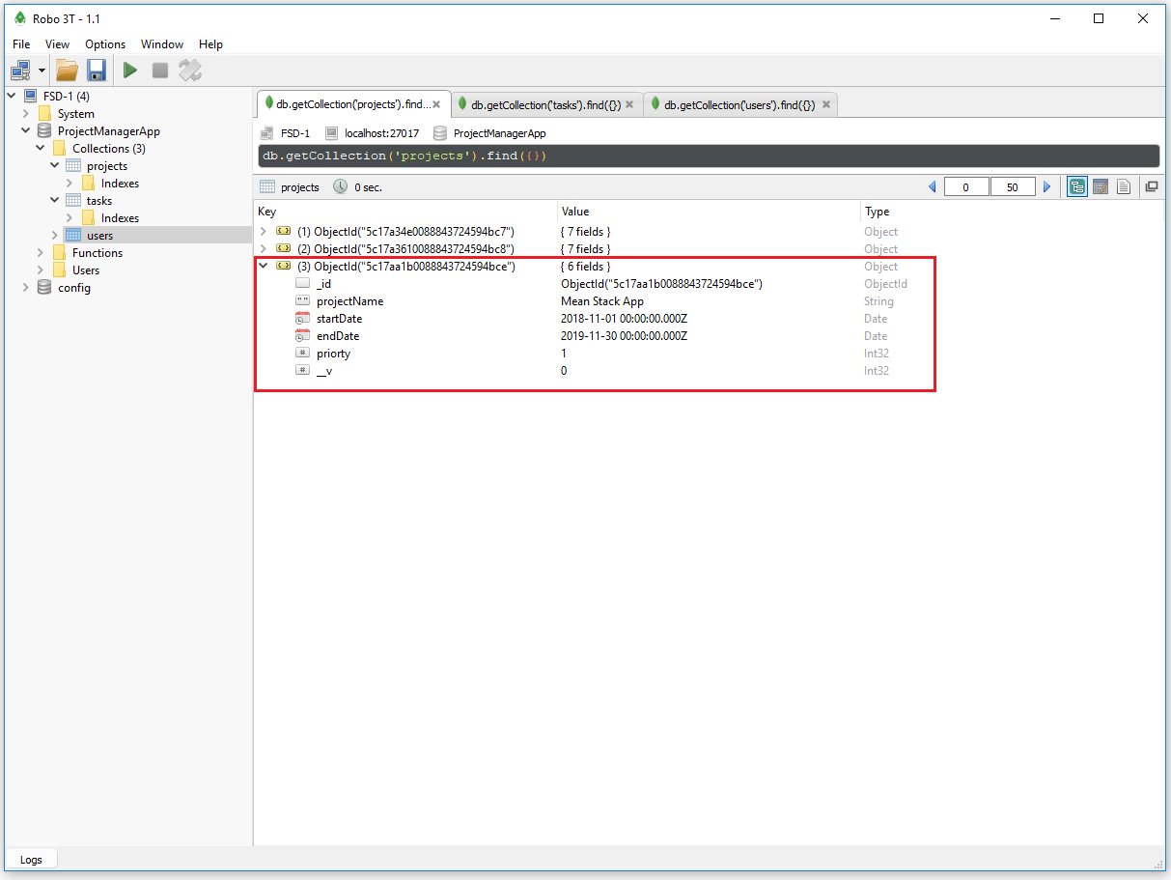

**View Project – Postman:**

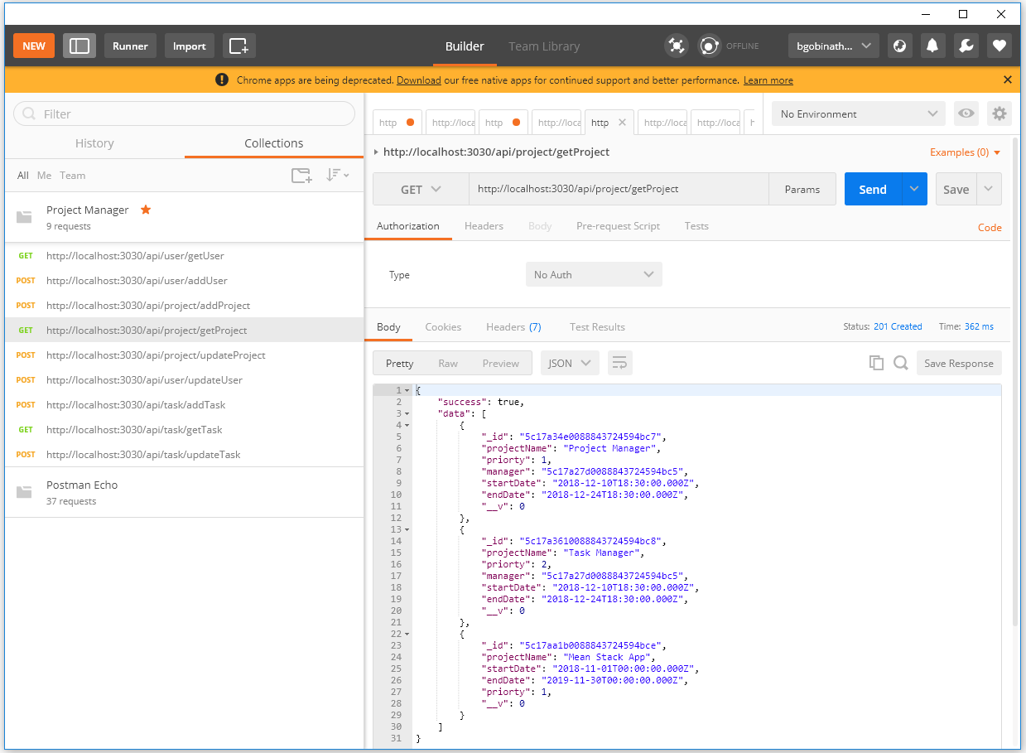

**View Project – MongoDB:**

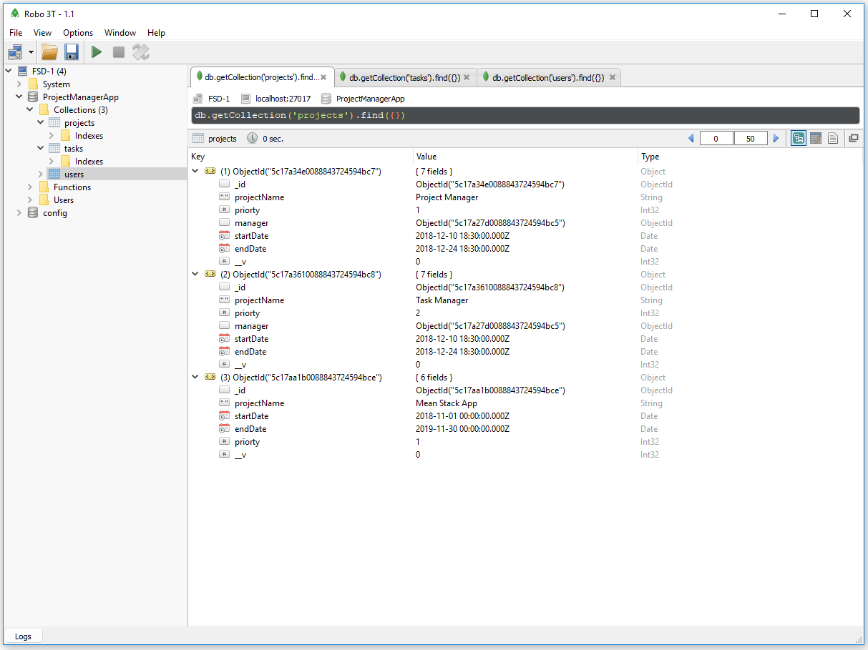

**Delete Project – Postman:**

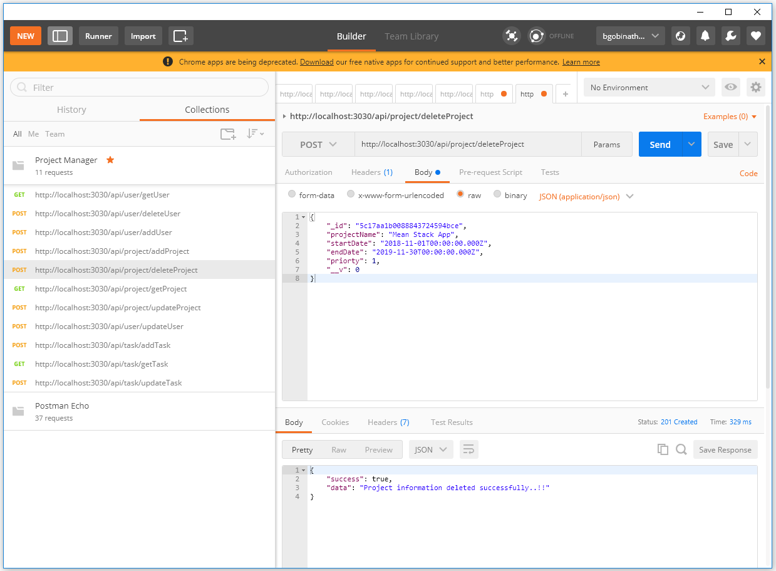

**Update Project – Postman:**

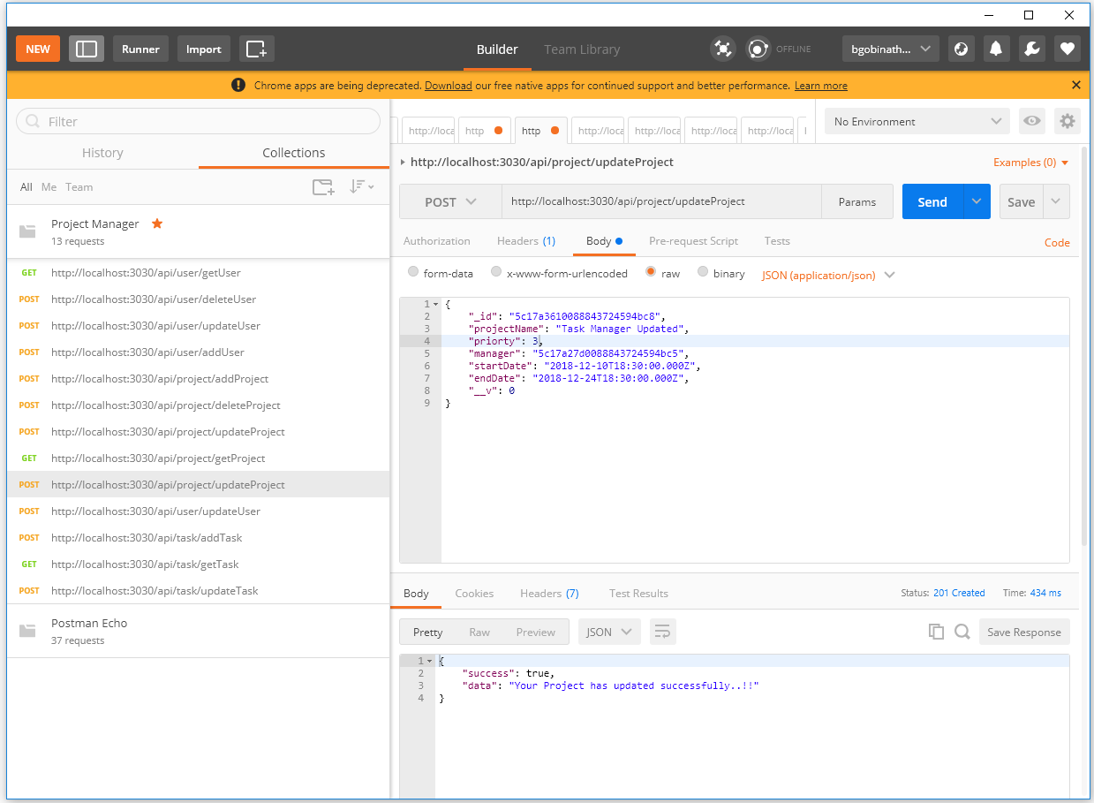

**Add Task – Postman:**

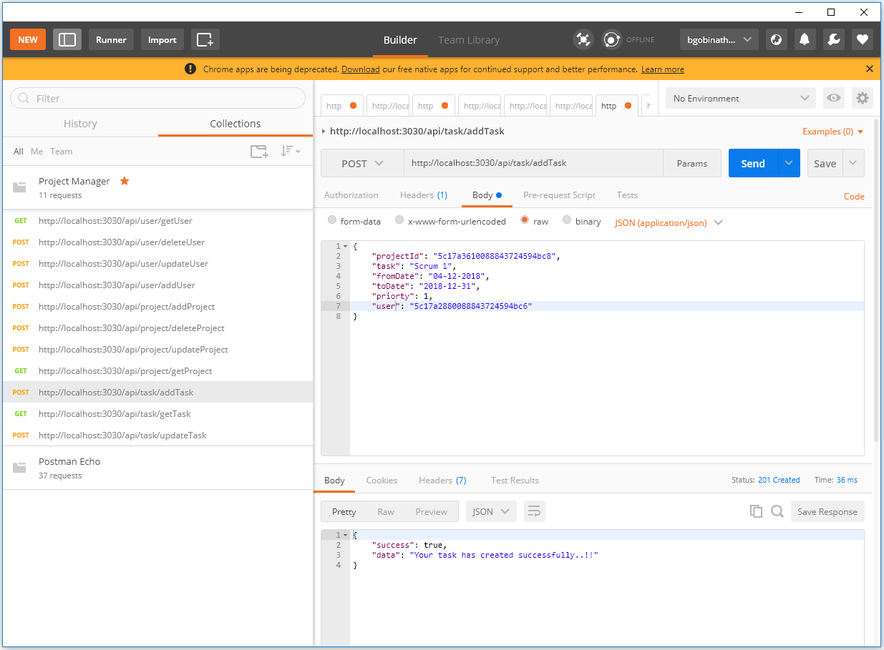

**Add Task – MongoDB:**

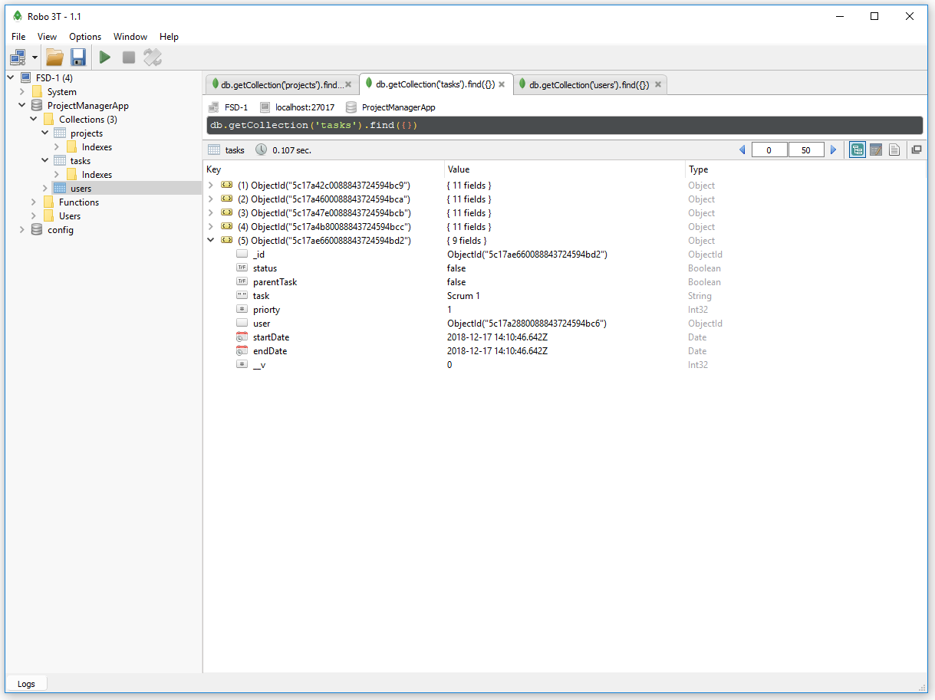

**Get Task – Postman:**

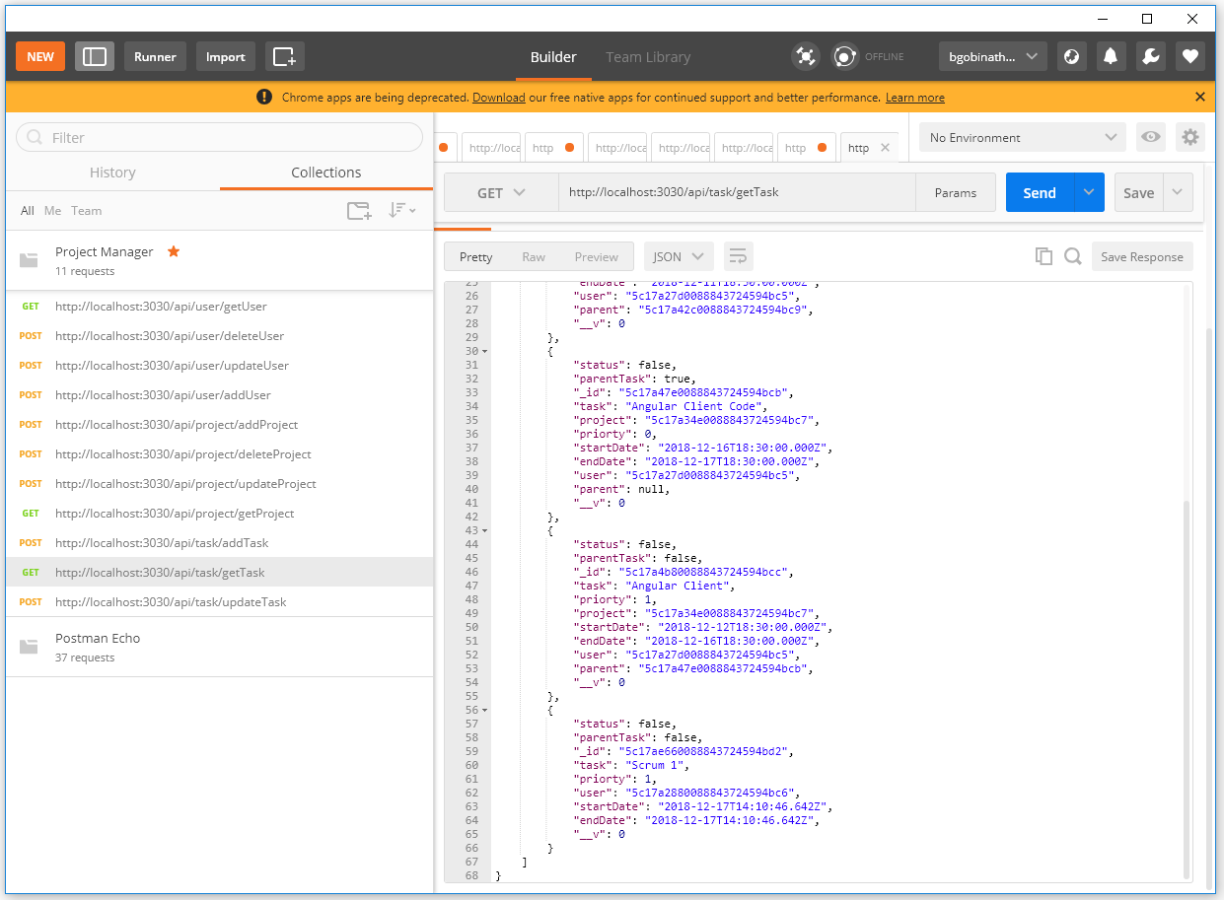

**Update Task – Postman:**

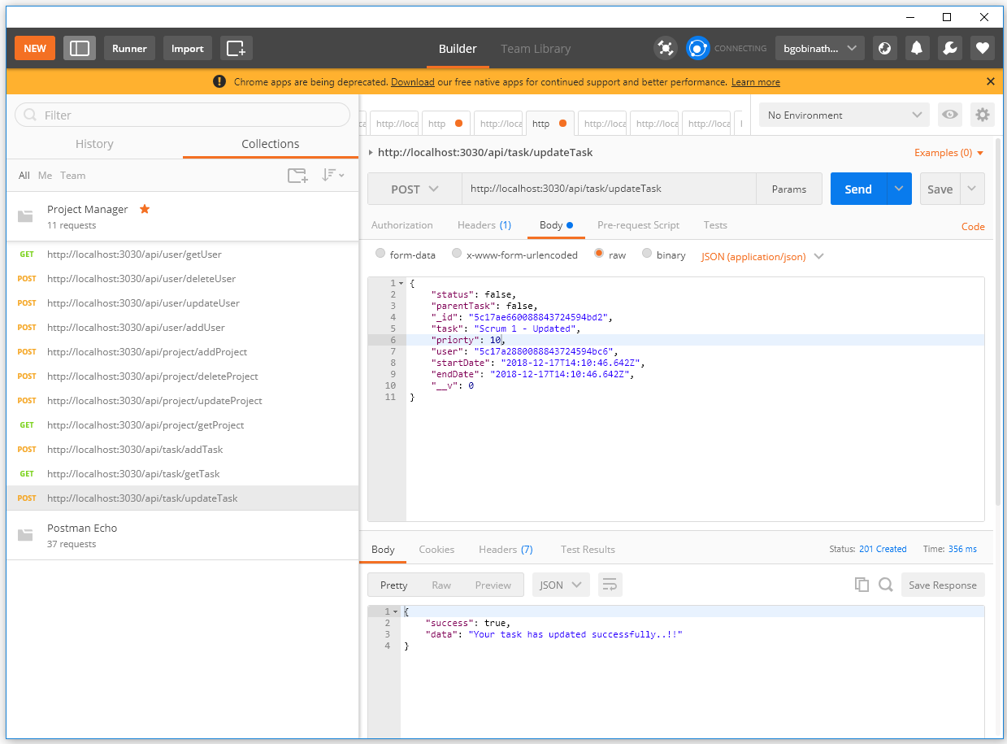

Start Application:

**Client Side – Angular:**

npm install

npm start

Hit <http://localhost:4200/> this url in browser

**Database – MongoDB:**

***Set DB path to run MongoDB:*** mongodb-4.0\bin>mongod –dbpath “...\project-manager\db”

**Server Side – Express:**

npm install

node app.js

Hit <http://localhost:3030/api/task/getTask> this url in POSTMAN to view the list tasks in GET method

Docker:

We have the below listed images and containers are available in Docker before we start implement.

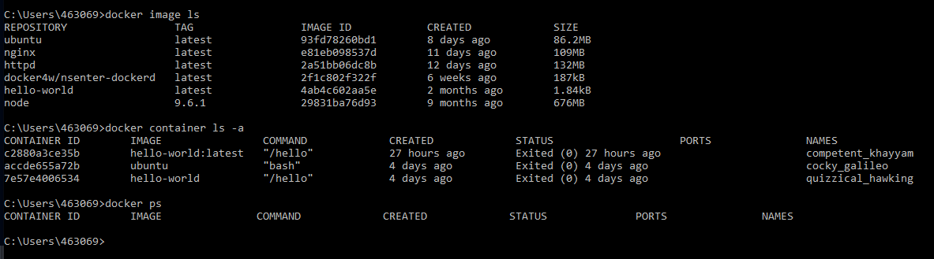

**Run:**

docker-compose up

This will install all the required packages for Angular, Express and MongoDB.

The below highlighted images are created and server is running to corresponding ports.

Client – Angular: <http://localhost:4200/>

Server – Express: <http://localhost:3030/api/task/getTask>

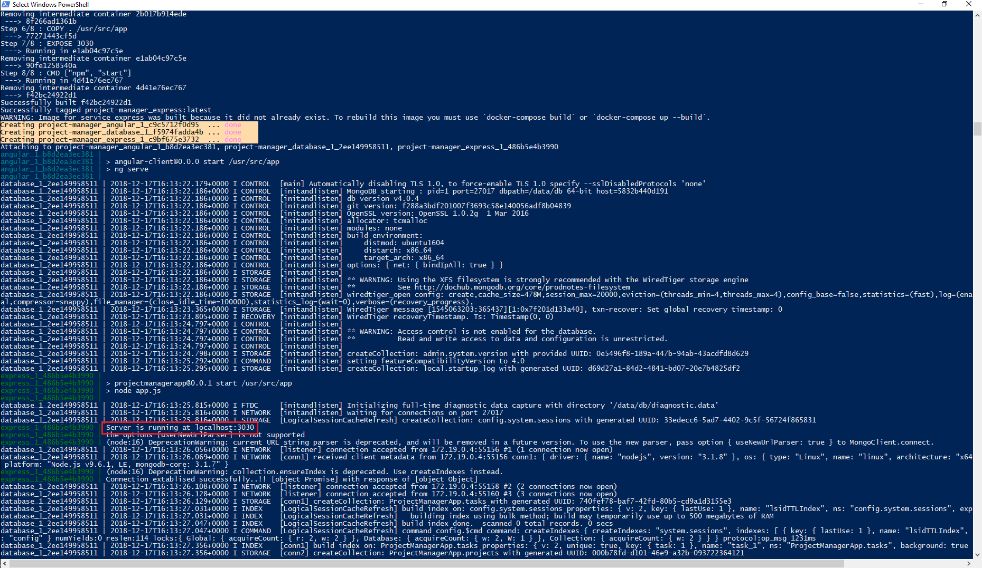

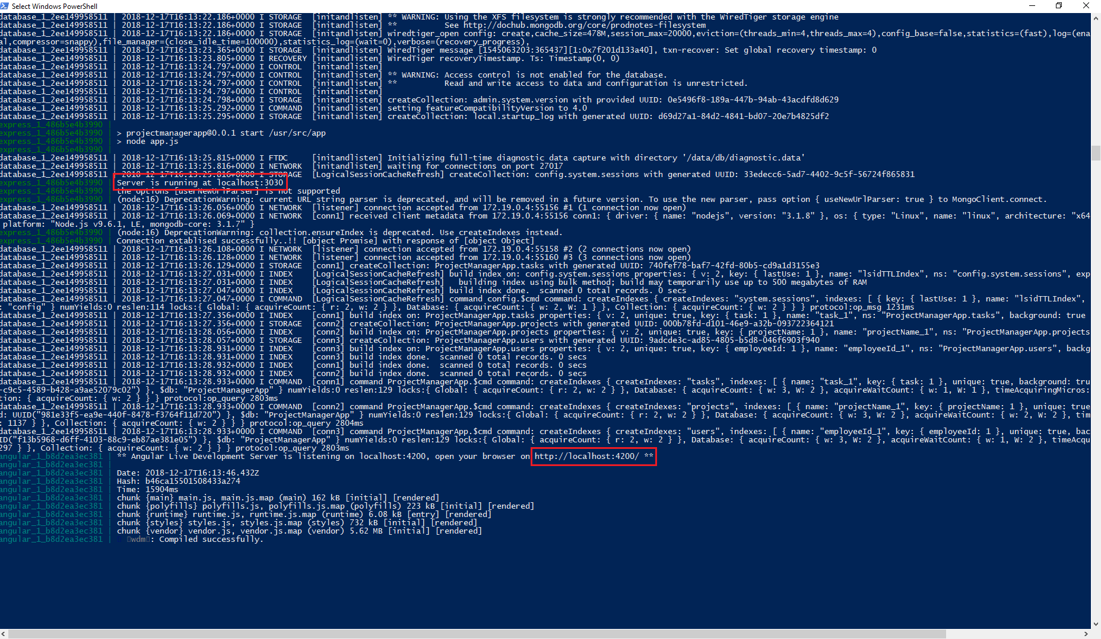

The below highlighted containers are up and running now.



**To hit the URL’s:**

docker exec –it <container_id> sh (Angular container_id e637b7ed39f5)

curl <http://localhost:4200/>

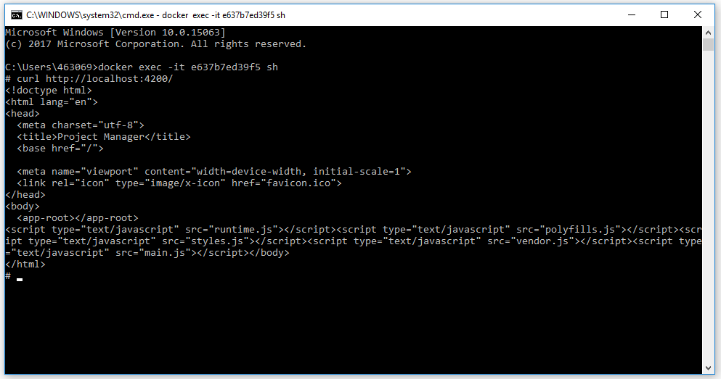

docker exec –it <container_id> sh (Express container_id b159fa977fca)

curl <http://localhost:3030/api/task/getTask>

curl <http://localhost:3030/api/project/getProject>

curl <http://localhost:3030/api/user/getUser>

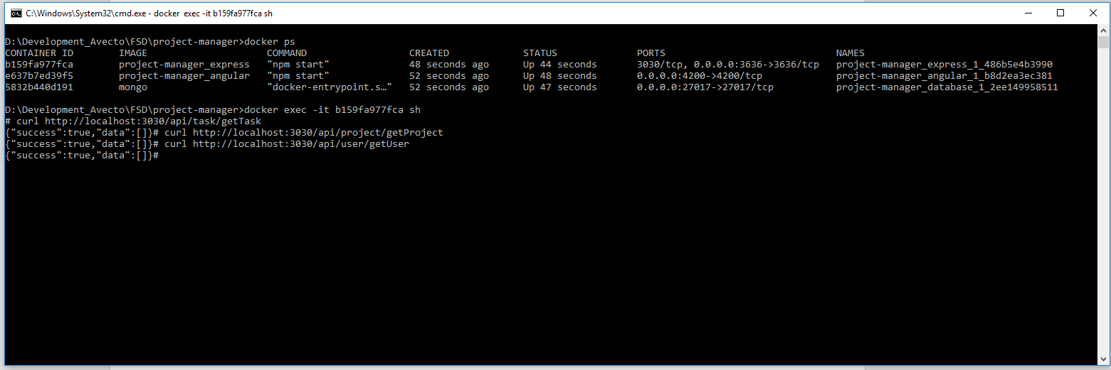

**Note:** I used windows 10 docker, windows port forwarding is not happening to check the URL in browser (application). So, I checked in curl and we are getting the proper response.

Git Repository: <https://github.com/gobinathgithub/project-manager.git>

Jenkins:

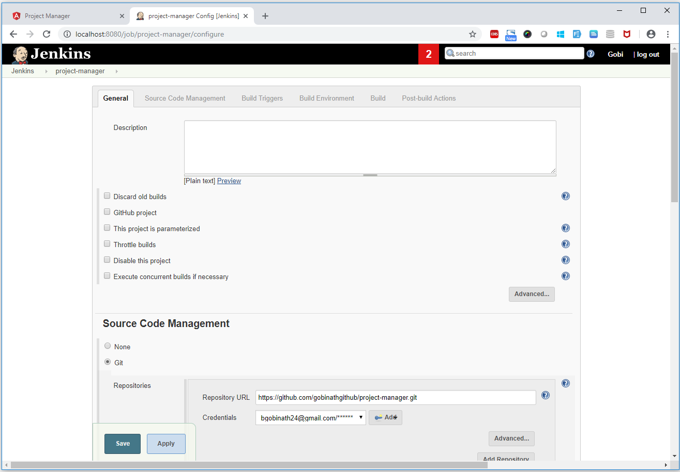

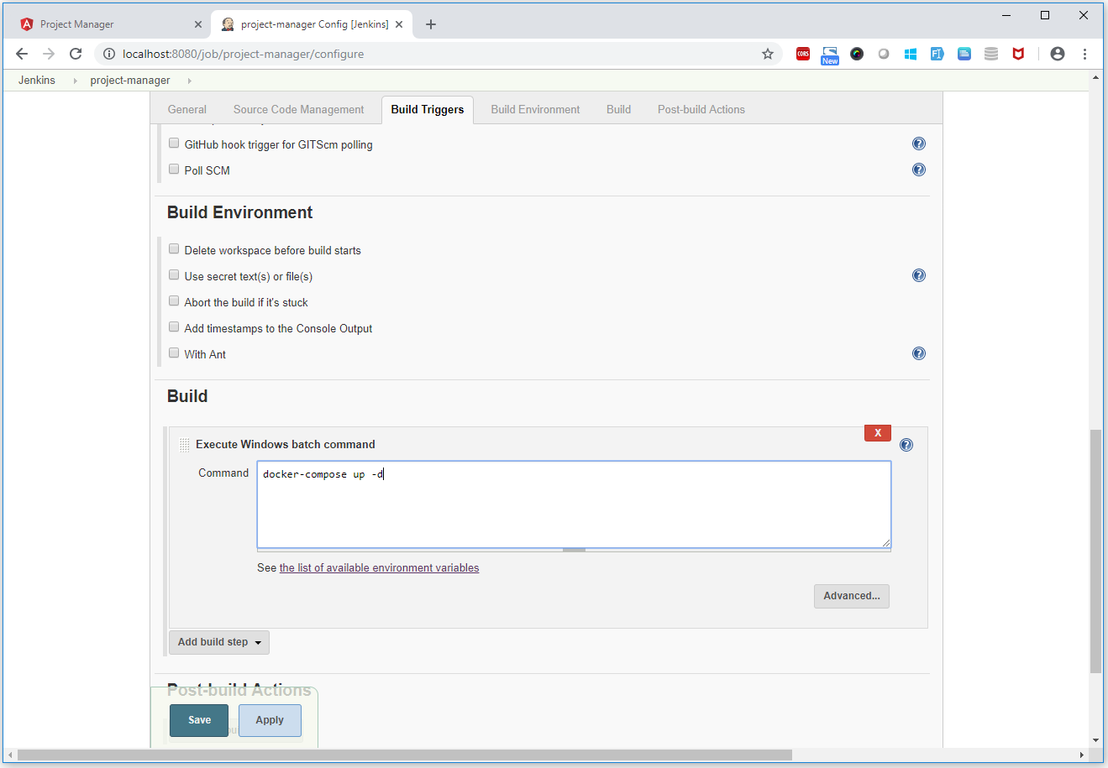

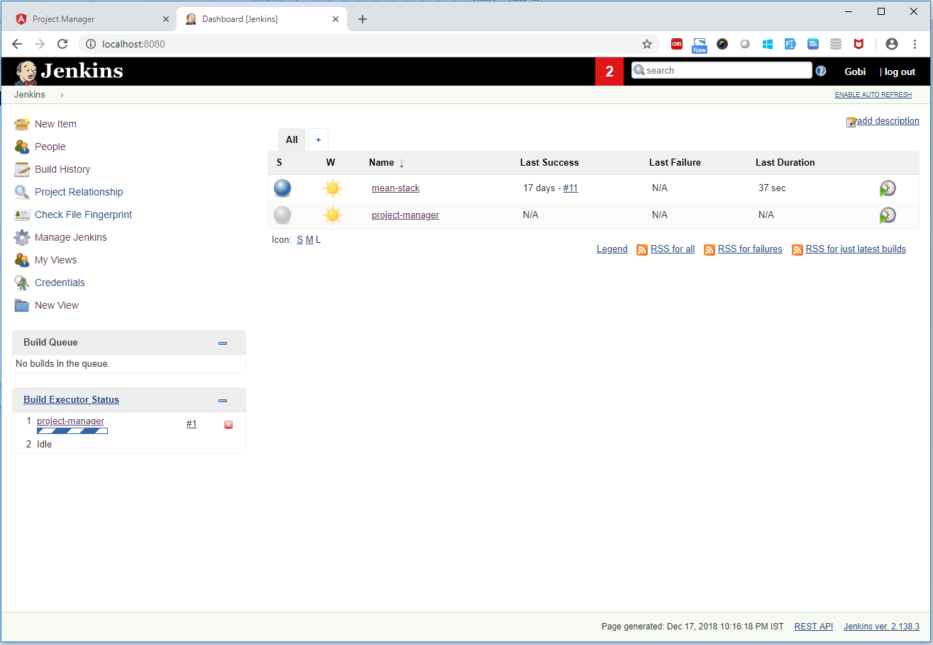

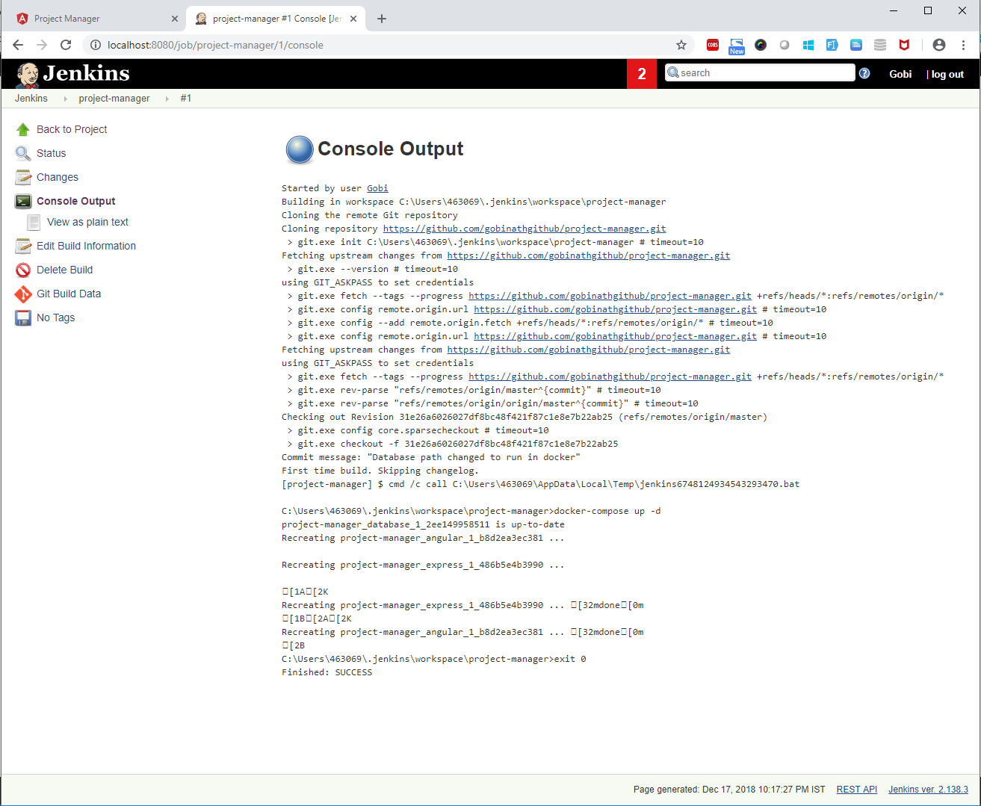

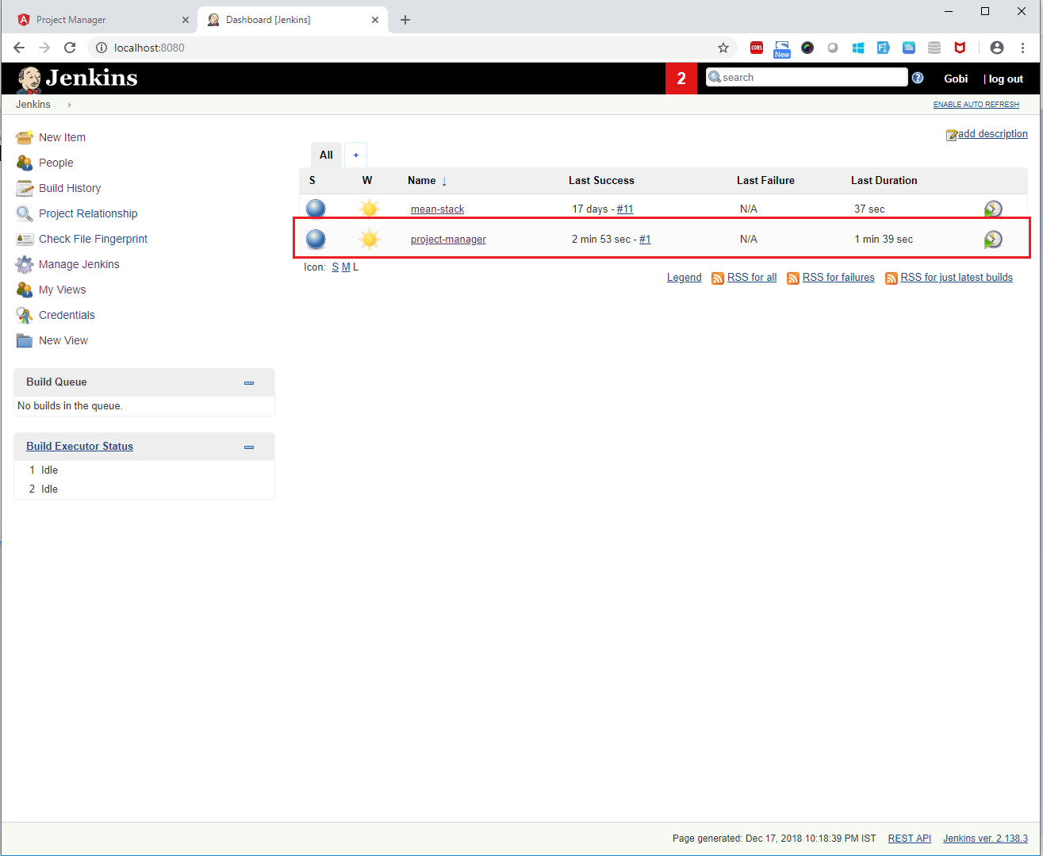

**Log file:**



**Container status**

